1. Let’s create formed-based authentication as we know as soon as we add spring security starter dependency, all the URLs are secured and one user is configured automatically and form-based authentication is enabled.
2. 
3. 
4. 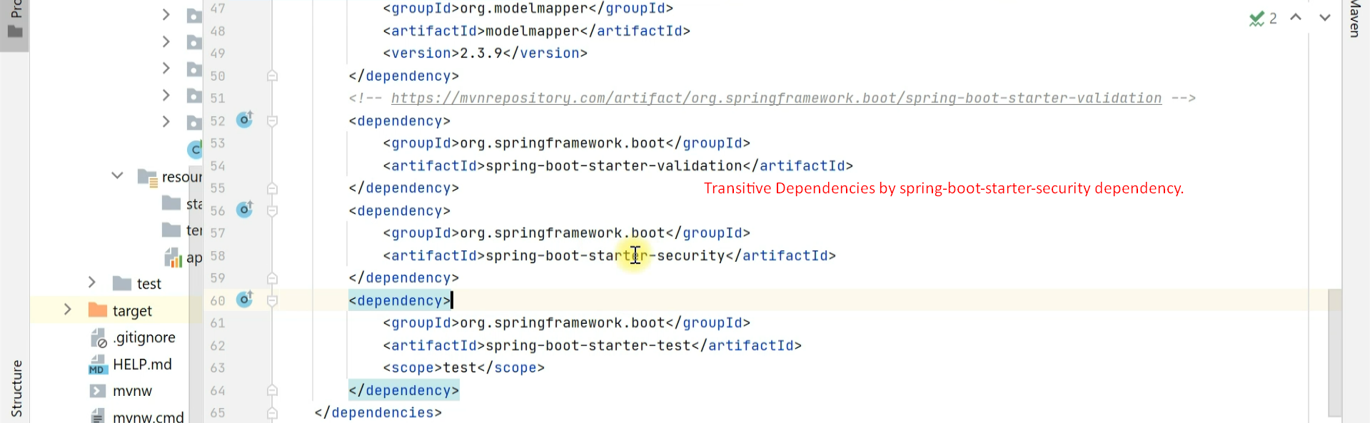
5. 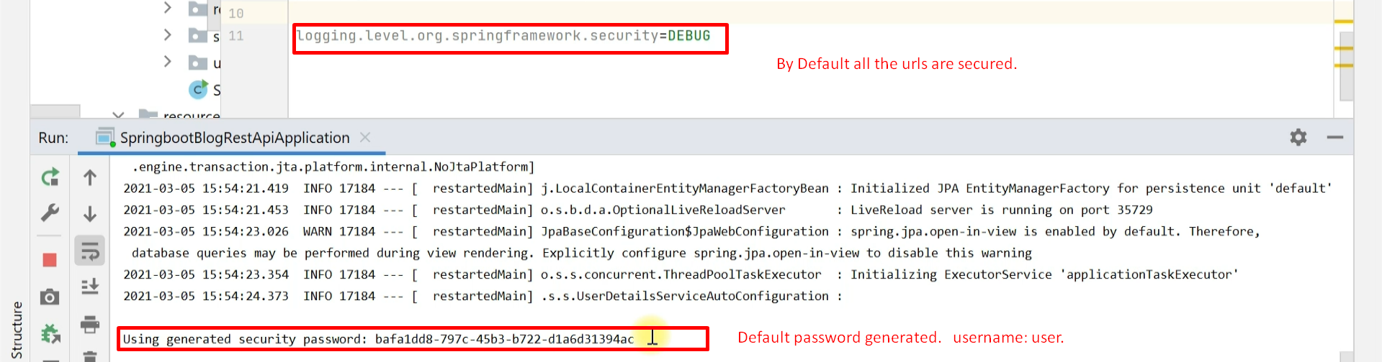
6. 
7. This is formed-based Authentication.
8. 